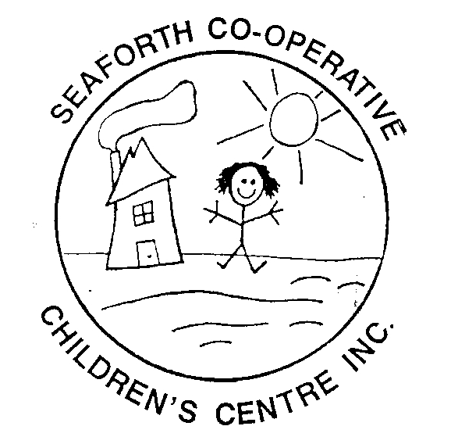

**Seaforth Co-operative Children’s Centre Inc.**

P.O. Box 347, 82 Chalk St. N., Seaforth, Ontario, N0K 1W0

Telephone: (519) 527-0682 Fax: (519) 600-0682

Email: sccc@tcc.on.ca

Facebook – Seaforth Co-operative Children’s Centre

Website – [www.seaforthchildcare.com](http://www.seaforthchildcare.com)

PARENT NEWSLETTER FEBRUARY 2020

Thanks to Gerry Gibbs for the donation of chocolate puddings and Effie McGrath for the donation of craft supplies and stickers.

**NEW PARENT FEES**

Parent fees are changing as of March 1, 2020. Please see the chart below.

|  |  |
| --- | --- |
| PROGRAM | RATE |
| Infant Full Day | $ 46.50 |
| Toddler Full Day | $ 37.00 |
| Preschool Full Day | $ 35.00 |
| School Age - Before **or** After | $ 10.00 |
| School Age – Before **and** After | $ 18.00 |
| School Age – Full Day | $ 30.00 |

**Reminders**

**The centre is closed Monday February 17 for Family Day.**

All calendars are due by the 15th of the month. Please make sure that your payment is sent in along with your calendar and that the payment method is filled out.

You can pay your fees by cash, cheques or e-transfer ([seaforthchildren@live.com](mailto:seaforthchildren@live.com)). When you are sending an e-transfer your child’s name must be included.

Childcare subsidy is available through Huron County please click the link below for the calculator

<https://www.huroncounty.ca/childrens-services/child-care-subsidy/calculator/>

**Up Coming Events**

 



**Fundraisers**

**Rheo Thompson**

We are selling Rheo Thompson mint smoothies for $2.50. If you are interested in selling them, please stop by the office, tell a staff or email me the amount you would like.



**River Valley Tube Passes**

We still have River Valley tube passes for sell for $20. They can get them at the office or at Blooms n’ Rooms.



**JD Sweid (Elmira Chicken)**

We will be running the JD Sweid fundraiser March 2 -13. Delivery date to be announced.



**Room Updates**

Infant Room: The infants are interested in Valentines’ Day, snow, mixing and sensory bottles.

Toddler Room: The toddlers have been interested in food, cooking, books and music.

Preschool Room: The preschoolers are interested in doing things outdoors, trains, dinosaurs and Valentines’ Day.

**Wish Lists**

Infant Room: Clear hair gel, doll beds and strollers, old pots and pans, cookie sheets and towels.

Toddler Room: Sleds and some shovels for outside, stickers, shaving cream, old pots & pans, old metal spoons & ladles and wooden spoons

Preschool Room: Flashlights (large or small), glue sticks, yarn, buttons, stickers, dress up clothes and rubber gloves.

**Kitchen**: Cindy is looking for clean 2 and 5gallon pails with lids and whole or half 45 gallon drums to use for her garden this year. Also, she is looking for lettuce, pepper, tomatoe, bean, cucumber, watermelon and carrot seeds.

Centre: We are looking for **boys** clothing size 6 months to size 5, underwear, socks and shoes. Girls pants size 2-5, underwear, socks and shoes.

**Learning Sign Language**

 

Rainy Sunny

 

Cloudy Windy



Snowy

If your are interested there is a site you can go to that can teach you some other words in sign language [www.lifeprint.com](http://www.lifeprint.com)





For those of you I haven’t met and those of you I have, here is some info about me. My name is Serena Donohue and I work with the senior school age children at SPS. I am 34 years old and the youngest of four girls. I live in Listowel and I also work at 123 Look At Me Nursery School. I don’t have any children myself, but I have 13 nieces and nephews, 2 great nephews and 1 great niece. I enjoy working with children, watching them learn and grow.

**Early ON Programs**

