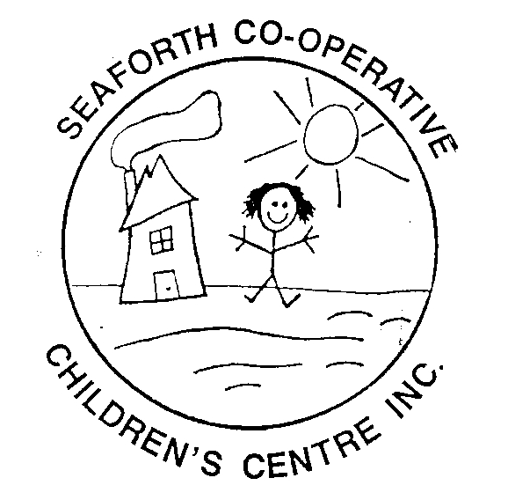
Seaforth Co-operative Children’s Centre Inc.
P.O. Box 347, 82 Chalk St. N., Seaforth, Ontario, N0K 1W0
Telephone: (519) 527-0682 Fax: (519) 600-0682
Email: sccc@tcc.on.ca
Facebook – Seaforth Co-operative Children’s Centre
Website – www.seaforthchildcare.com

PARENT NEWSLETTER SEPTEMBER 2019

Thanks to Jaclyn Henderson and Rachel Leslie for the clothing donations. Melissa Veldman for the construction paper, Ashton Crawford for the various craft supplies and Bruce McKenzie for the bird houses.

Reminders

We have revamped our website page, please check it out at
www.seaforthchildcare.com

All calendars are due by the 15th of the month. Spaces are filled on a first come, first serve basis.

Please label all your children’s belongings. We have an ongoing Mabel’s Labels fundraiser, if you are interested.

You can pay your fees by cash, cheques or e-transfer (seaforthchildren@live.com). When you are sending an e-transfer your child’s name must be included.

We are a nut free centre, so no outside food is allowed.

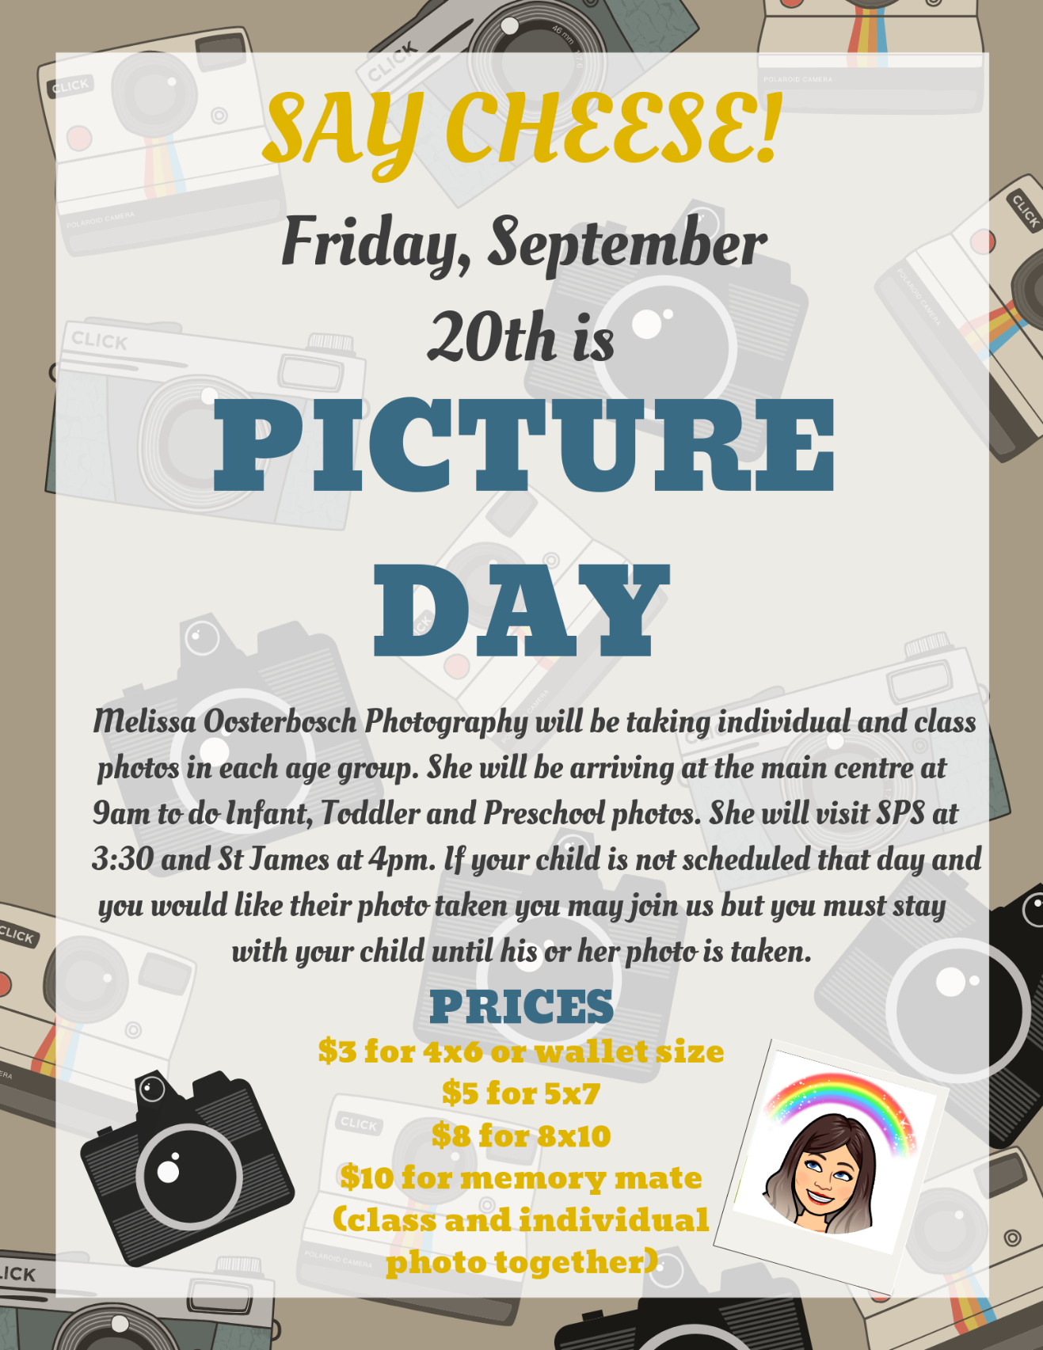

Room Updates

Infant Room: The infants are interested in vehicles (going for walks to look for or at vehicles, riding the plasma cars, painting the cars and bikes), family (making a family photo book) and anything to do with sensory.

Toddler Room: The toddlers have been interested in butterflies and caterpillars (hunting for butterflies and caterpillars, pretending to be caterpillars and butterflies), tractors (playing with tractors in oatmeal in the sensory bin) and colours (colour match games).

Preschool Room: The preschoolers have been interested in firefighters (pretending to be firefighters, making fire extinguishers) and firetrucks (making a fire truck out of a cardboard box)

Wish Lists

Infant Room: Bird seed (peanut free), large plastic animals, empty baby wipe containers, board books and tissue paper

Toddler Room: Hot Wheel vehicles, small red paper plates, extra large beads, old pots & pans, old metal spoons & ladles, wooden spoons, ribbon, farm animal and car magazines, metal cookie sheets, trays for paint, empty plastic water bottles, board books and coloured gems.

Preschool Room: Large cardboard box, magazines, maps, books and old greeting card, tape (all different kinds), binoculars, small balls, large foam sponges, grass seed, outside thermometer, flashlights, old watches, jewelry and playdough.

Centre: 2-3 straw bales, corn stalks and pumpkins or gourds

Learning Sign Language

Cow Horse

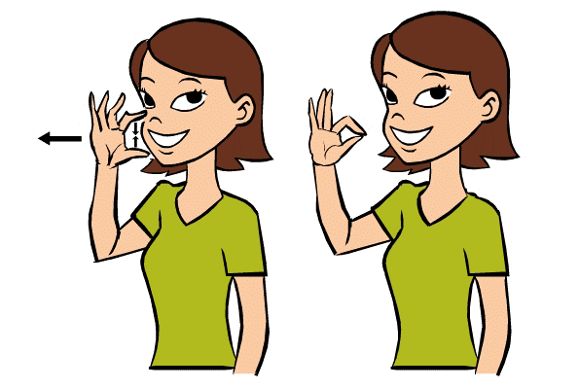
Cat Dog

Duck Rabbit

If your are interested there is a site you can go to that can teach you some other words in sign language www.lifeprint.com

Featured Staff of the Month

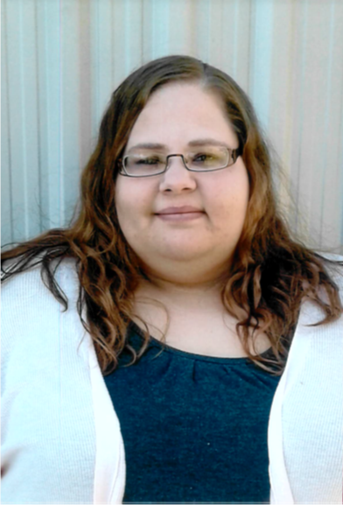

Hello, my name is Tracy. I graduated from Mohawk College in June 2014 with a diploma in Early Childhood Education. I have been working at SCCC for 3 years. Most of my time is spent at SPS off site program. You will often see me in the classrooms at the daycare during the day covering lunch breaks. I have been working with children since the age of 12 when I started babysitting, then started working in the children’s programs at my church in my teens.

In my free time I enjoy reading, gardening, spending time with my family, listening to music and baking treats.

I love getting to spend time working with your children and I always look forward to getting to know you as well. Don’t be afraid to stop and say hello wherever you may see me during the day.

Early ON Programs

Gym Night (0-6 years)
Tuesdays 6 pm – 7:30 pm
St. James Catholic School

Baby Time (0-12 months)
Wednesdays 10am- 11:30 am
Seaforth Library

Kirkton Play Group (0-6 years)
Thursdays 10am- 11:30 am
Kirkton Community Centre

Northside Play Group (0-6 years)
Fridays 10am-11:30 am
Northside United Church

